## DOCUMENTATION HADR

**PREREQUISTIES**

* DB2 installed on both machine should be of same version(here we have used db2 version 10.5).
* A reliable TCP/IP interface must be available between the HADR servers.
* **C:\Windows\System32\drivers\etc**

DC.Primary 192.168.1.49

DR.standby 192.168.1.181

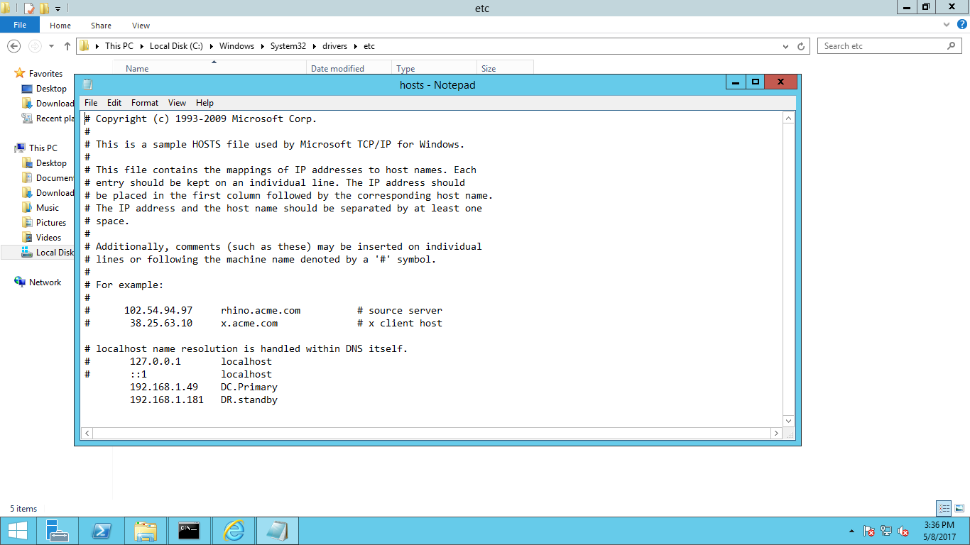

* **Enter HADR port in services file:**
* **C:\Windows\System32\drivers\etc**

Hadr_service_primary 51012/tcp

Hadr_service_standby 51013/tcp

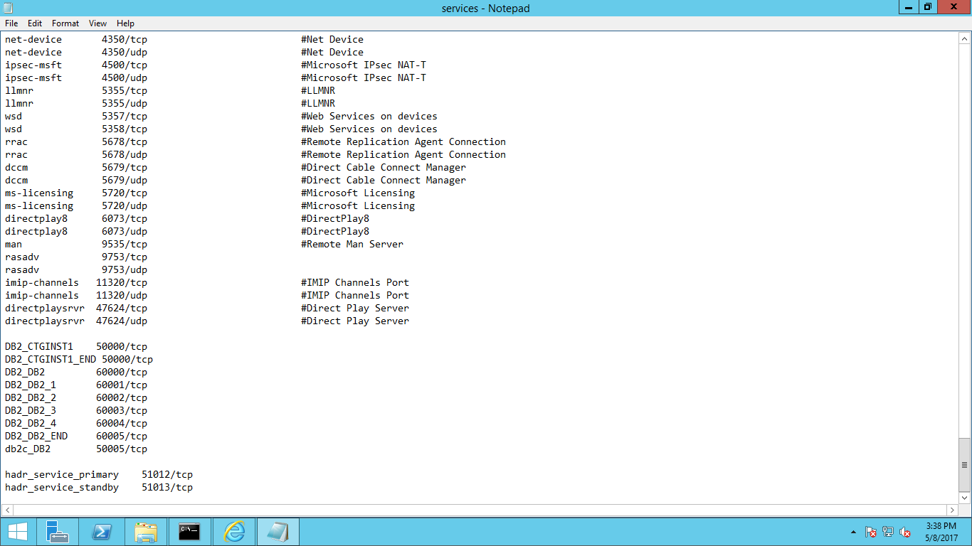

* Both environment must ping each other by ‘fully qualified host name’ and ‘IP address’.
* Client communicate with DB2 instance through port 50000 and DB2 hadr server communicate with each other through port 51012 and 51013.
* Db2 instance name, instance port and database name should be same on both machine.
* The port is the one with which client connect to DB2.
* When you perform backup and restore database should be successfully deactivated at that time.

**PRIMARY**

* For set up an instance run the following command:
* db2ilist
* db2 get instance
* Set db2instance=CTGINST1
* db2 activate db maxdb76
* **Update the database configuration parameters on the primary database server:**
* db2 update db cfg for maxdb76 using hadr_local_host DC.Primary
* db2 update db cfg for maxdb76 using hadr_remote_host DR.standby
* db2 update db cfg for maxdb76 using hadr_local_svc 51012
* db2 update db cfg for maxdb76 using hadr_remote_svc 51013
* db2 update db cfg for maxdb76 using hadr_remote_inst CTGINST1
* db2 update db cfg for maxdb76 using hadr_timeout 1000
* db2 update db cfg for maxdb76 using hadr_peer_window 600
* db2 update db cfg for maxdb76 using logarchmeth1 logretain
* db2 update db cfg for maxdb76 using logindexbuild on
* db2 update db cfg for maxdb76 using hadr_syncmode nearsync
* db2 update alternate server for database maxdb76 using hostname 192.168.1.181(ip of standby database server) port 50000
* db2 deactivate db maxdb76
* db2 backup db maxdb76 to C:\user\administrator\....(this is the path where you take your backup).

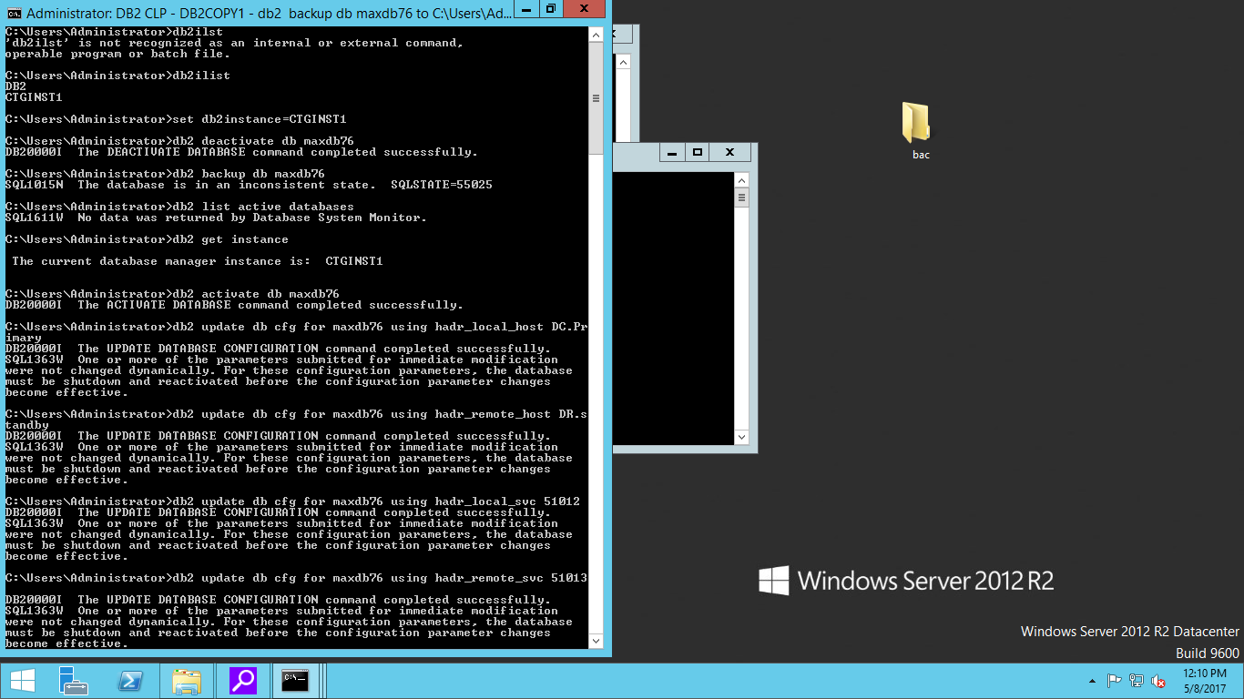

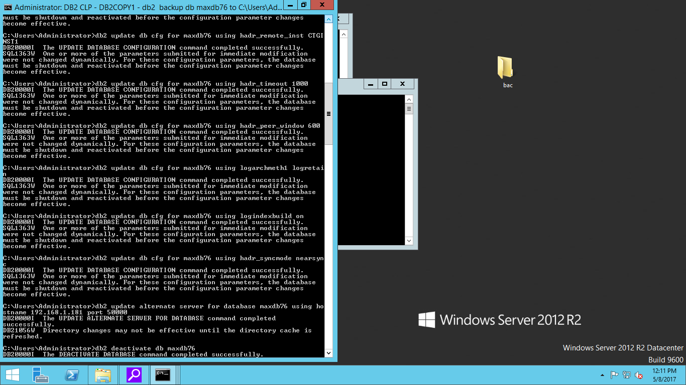

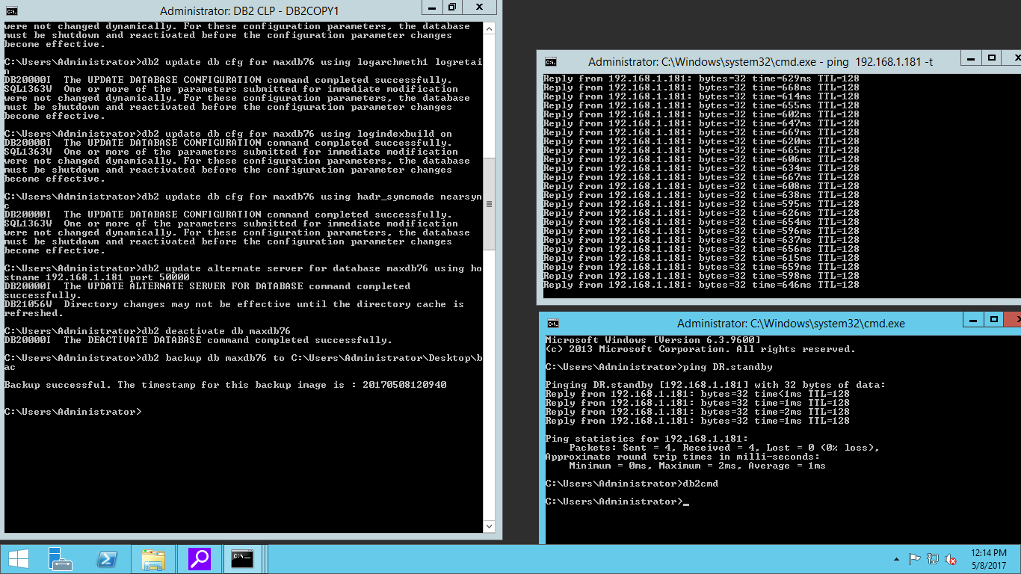

* **We can check the HADR configuration by running the following db2 command:**
* db2 get db cfg for maxdb76
* **Copy that Primary Database backup image into Standby Database in the same path.**

**STANDBY**

* Run the following commands:
* Db2ilist
* Db2 get instance
* Set db2instance=CTGINST1
* db2 activate db maxdb76
* db2 connect to maxdb76
* db2 deactivate db maxdb76
* If database not deactivated successfully then power off machine and logon to the machine again.
* Set the instance again.
* Run database deactivate command again.
* Then run the following command:

db2 restore db maxdb76 from (that folder path) taken at (that time stamp image e.g. 20170508120940

* **After running the restore command update the database configuration parameters on the Standby database server by the following command**:
* db2 update db cfg for maxdb76 using hadr_local_host DR.standby
* db2 update db cfg for maxdb76 using hadr_remot_host DC.Primary
* db2 update db cfg for maxdb76 using hadr_local_svc 51013
* db2 update db cfg for maxdb76 using hadr_remote_svc 51012
* db2 update alternate server for database maxdb76 using hostname 192.168.1.49(ip of primary database server) port 50000.



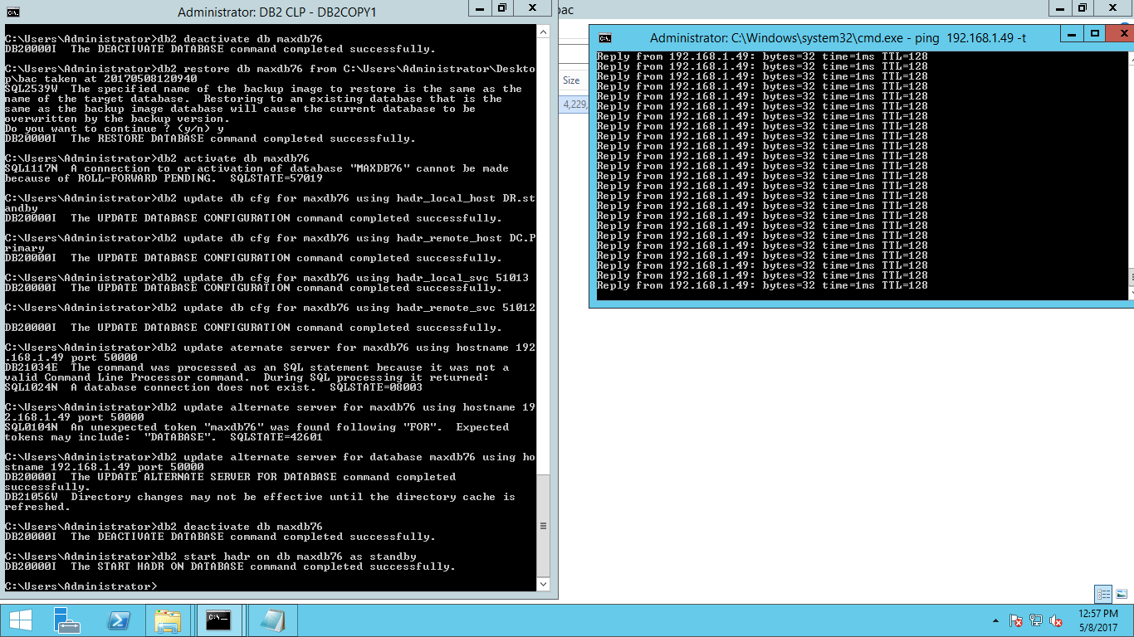

* **After the configuration of both database server by HADR run the following command:**

**On Standby Database Server:**

* db2 deactivate db maxdb76
* db2 start hard on db maxdb76 as standby



**On Primary Database Server:**

* db2 activate db maxdb76
* db2 start hard on db maxdb76 as primary

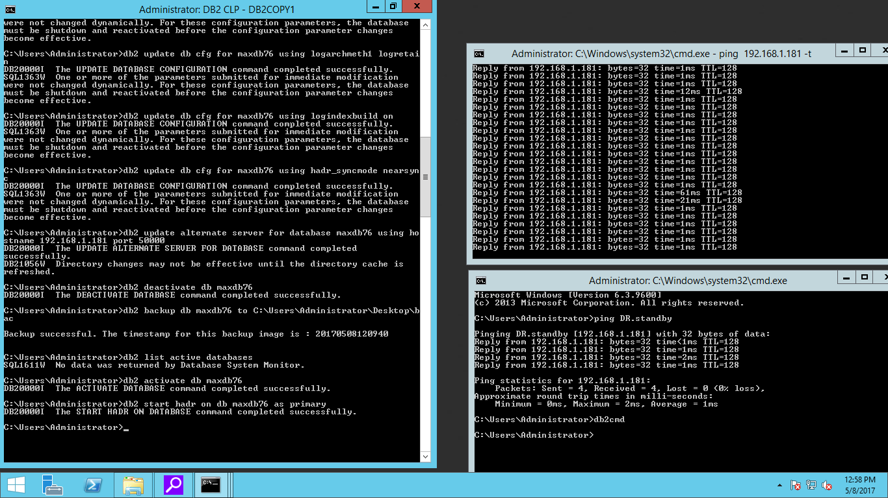

* **To check the configuration parameter and hard status whether it is connected or not run the following commands on both primary and standby database server**:
* db2pd –hadr –db maxdb76

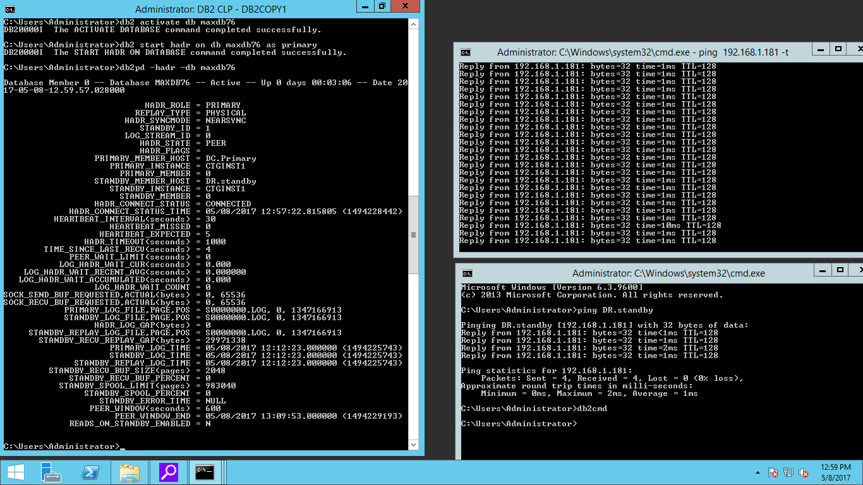  
  
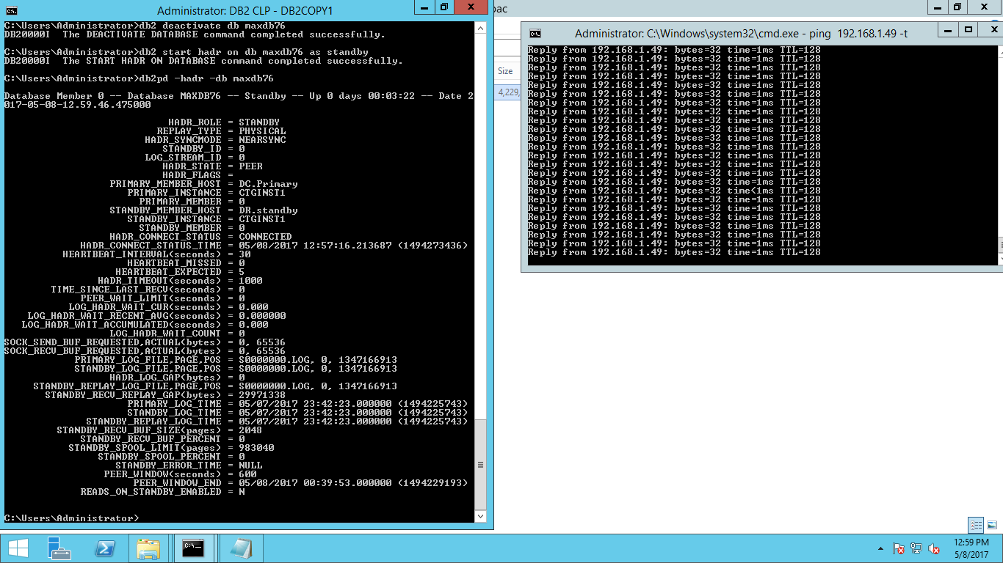

* **Swith role between Primary and Standby Database Server run the following command only on standby database server:**
* db2 takeover hard on db maxdb76

**Note:**  after running the takeover command on standby database server primary   
 database server automatically take role as standby database server.

**On Standby**

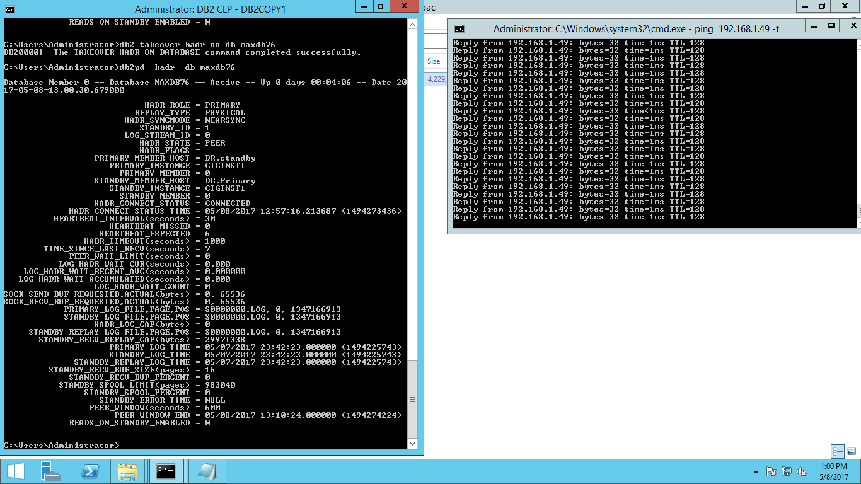

**On Primary**

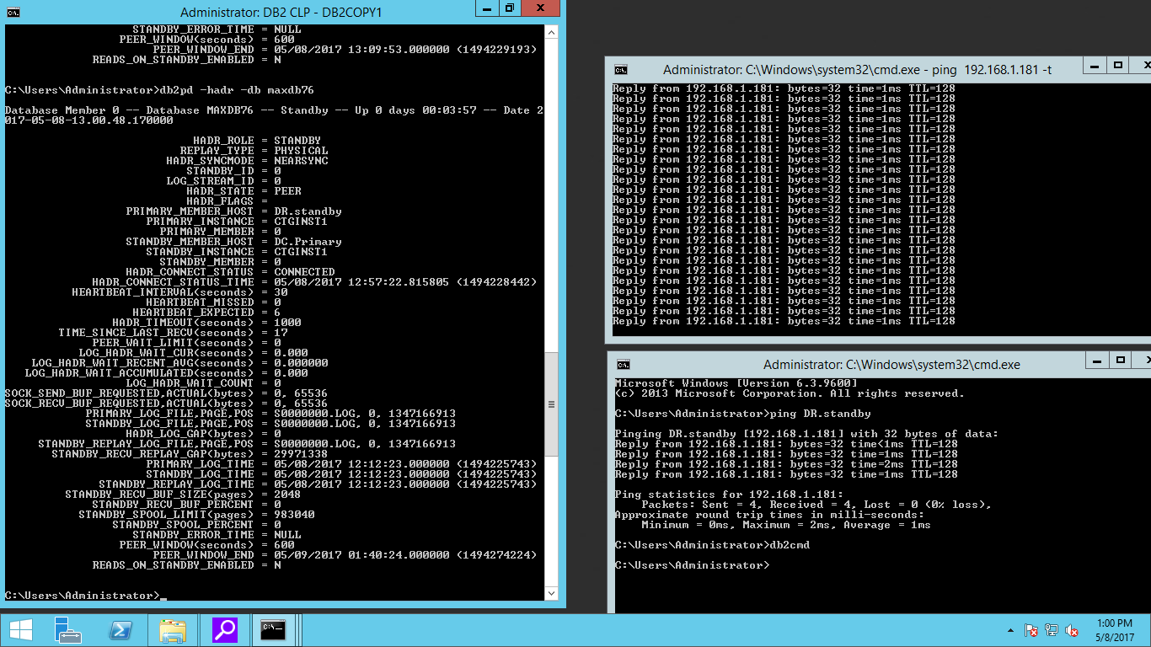

**TESTING**

* For testing raise ticket on Primary database server VM then run takeover command on standby database server and connect standby database server vm to Aqua data studio and check that raised ticket on it.

**On Primary**:

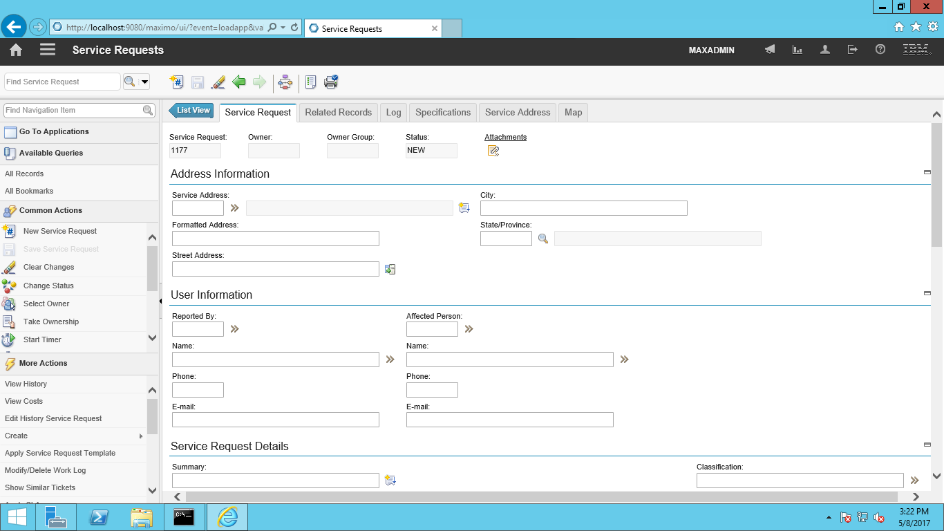

**On Standby**:



* **On AQUA connect to standby database server and check raised ticket after running takeover command**:

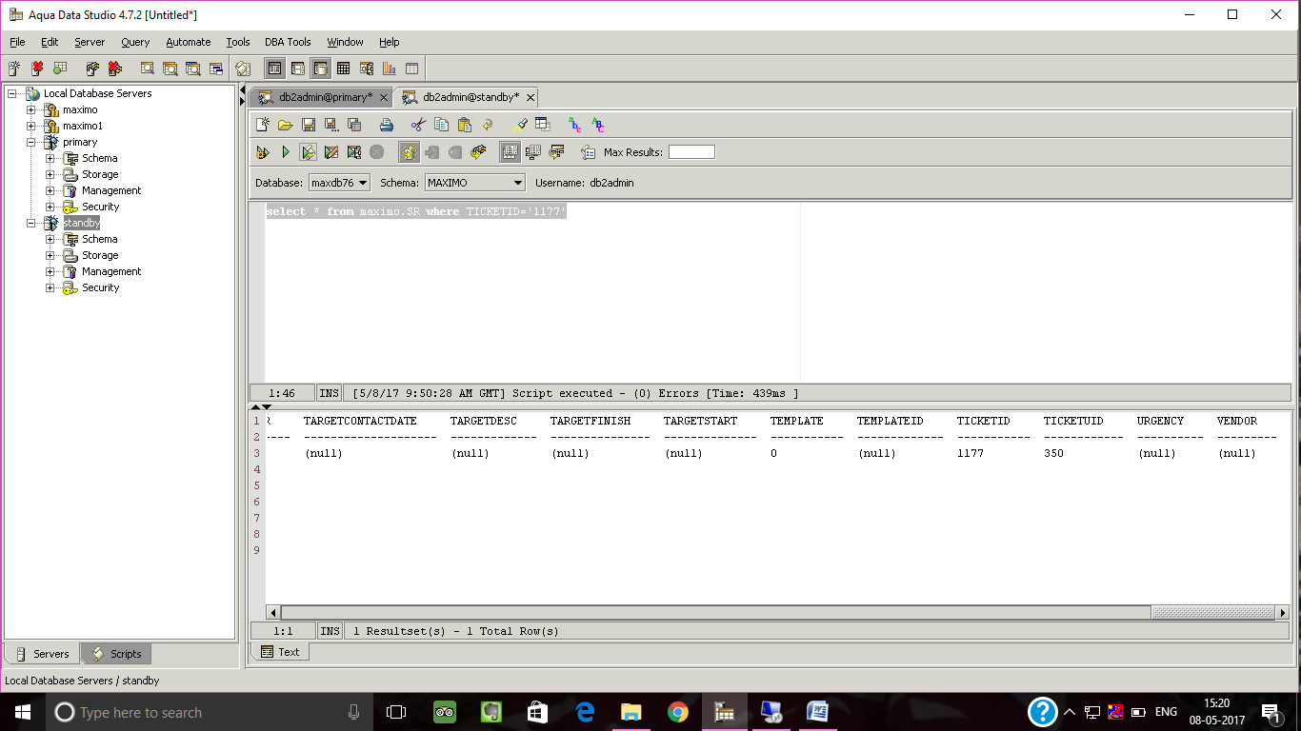

* **Similarly when Standby take role of primary database server raised ticket on it, connect Primary database server (which at present act as standby ) to Aqua and check raised ticket**:

